My Plant Pal
VictorDelgadoJ-Ops/My-Plant-Pal

1. Overview
My Plant Pal is a desktop application built with Python and Tkinter that helps users track their houseplants, watering schedules, sunlight needs, and plant health. The app includes a modern dark/light theme system, image support, toast notifications, and a dashboard that summarizes plant status briefly.
The program stores plant data in a local JSON file, allowing the user’s plant list to persist between sessions.
2. Key Features
Dashboard
- Displays total plants, plants needing water today, and overdue plants.
- Shows a visual health bar summarizing healthy vs. due vs. overdue plants.
- Quick-action buttons for adding plants or viewing the plant list.
Plant Management
- Add new plants with:
  - Name
  - Watering frequency
  - Sunlight level
  - Optional image
- View plant details, including last watered date and thumbnail.
- Mark plants as watered.
- Delete plants from the list.
- Search bar for filtering plants by name.
Themes
- Toggle between Light Mode and Dark Mode.
- All UI elements update instantly when switching themes.
Notifications
- Toast pop-ups appear for:
  - Successful actions
  - Missing input
  - Watering reminders
- Reminders automatically appear at startup for plants due or overdue.
Data Persistence
- Plant data is saved to plants.json.
- Automatically loads saved plants when the app starts.
3. How to Use the Application
Starting the App
- Run the program using Python:
Code
python my_plant_pal.py
- The dashboard loads first, showing plant statistics and quick actions.
Adding a Plant
- Click “Add Plant” from the dashboard or plants page.
- Enter:
  - Plant name
  - Watering frequency (days)
  - Sunlight level (Low/Medium/High)
  - Optional image path
- Click Save Plant.
- A toast notification confirms the plant was added.
Viewing and Managing Plants
- Click “Plants” in the header.
- Use the search bar to filter by name.
- Select a plant too:
  - View details
  - Mark as watered
  - Delete the plant
- Click Save Plants to write changes to the JSON file.
Theme Switching
- Click the header “Light Mode” or “Dark Mode” in the header.
- The entire UI updates instantly.
Watering Reminders
- When the app starts, it checks all plants.
- If any are due or overdue, a toast notification appears listing them.
4. Screenshots of working app should look like
Screenshot 1 – Dashboard
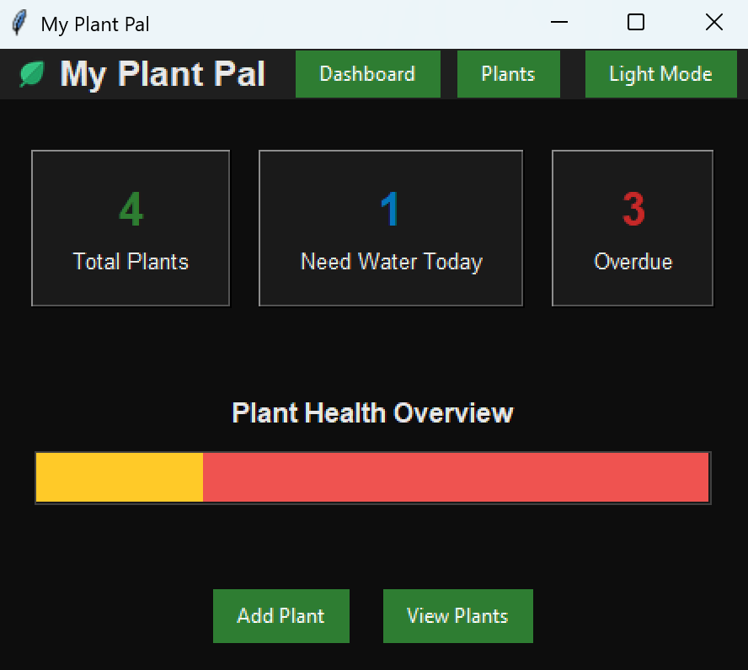
Screenshot 2 – Plants Page
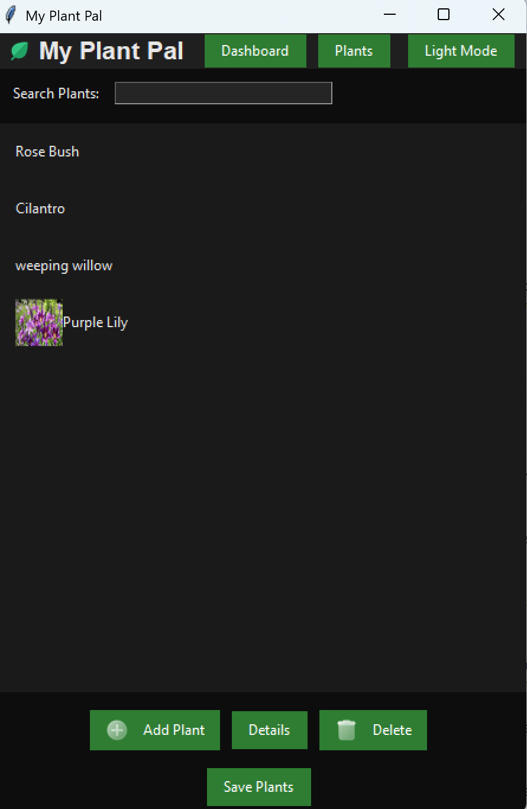
Screenshot 3 – Add Plant Window or Details Window
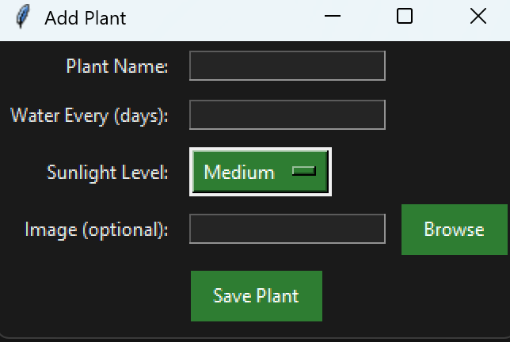
5. Technical Notes
Languages & Libraries
- Python 3.14
- Tkinter (GUI)
- PIL / Pillow (image handling)
- JSON (data storage)
File Structure
Code
My-Plant-Pal/
│
├── my_plant_pal.py
├── plants.json
└── images/
├── add.png
├── delete.png
├── leaf.png
├── water.png
└── default.png
Data Format (plants.json)
Each plant is stored as:
json
{
"name": "Aloe Vera",
"water": 7,
"sun": "High",
"image": "path/to/image.jpg",
"last_watered": "2026-03-05"
}
6. Summary
My Plant Pal is a polished, theme-aware plant tracking application with persistent storage, image support, and a clean UI. It demonstrates strong use of Tkinter widgets, event handling, custom styling, and modular design.

My Plant Pal — Project Status Report
2/22/2026
1. Completed Work
You’ve made substantial progress on the app, and the project now includes several polished, portfolio-ready features:
Core Features Implemented
- Sunlight Level Dropdown Allows users to select sunlight requirements for each plant.
- Plant Images + Thumbnails Users can attach images; thumbnails now appear in the plant list.
- JSON Save/Load System Plant data persists between sessions using a clean JSON structure.
- Watering Reminder Foundation Basic logic is in place to track watering frequency and next watering date.
UI/UX Improvements
- Modernized Interface with:
  - Rounded buttons
  - Hover animations
  - A solid header bar
  - PNG icons stored in an images/ folder
  - Light/Dark mode toggle
  - Card-style plant list with thumbnails
This moves the app closer to a professional, app-store-ready design.
2. Problems Encountered
Technical Issues
- Hover animations were unstable Early versions caused flickering or inconsistent behavior until the event bindings were cleaned up.
- JSON load errors Missing keys in older save files caused crashes until default values and validation were added.
- Image path inconsistencies Relative vs. absolute paths caused images to fail when loading from different directories.
- Layout alignment issues Thumbnails and text didn’t align cleanly until the frame/grid structure was adjusted.
Workflow Challenges
- Integrating new UI elements without breaking the existing layout
- Ensuring the theme system applied consistently across all widgets
- Maintaining modular code while adding new features
3. Next Steps
Upcoming Features
- Search Bar Allow users to quickly find plants by name.
- Sorting Options Sort by A–Z, last watered, sunlight level, etc.
- Settings Menu Central place for theme toggle, default image folder, and reminder preferences.
- Dashboard / Stats Page Show total plants, overdue waterings, upcoming reminders, etc.
- Improved Reminder System Notifications, color-coded alerts, and better date tracking.
2/25/2025
A brand-new dashboard appears when the app launches. It includes:
Stat Cards
- Total Plants
- Need Water Today
- Overdue
Health Bar Visualization
A horizontal bar showing:
- Healthy
- Due Today
- Overdue
Quick Action Buttons
- Add Plant
- View Plants
This gives the app a modern, “overview-first” feel.
2. Header Navigation
The header now includes:
- Dashboard button
- Plants button
- Dark Mode toggle
This replaces the old single-page layout with a clean, app-like navigation system.
3. Page Switching System
Two main frames now exist:
- dashboard_frame
- plants_frame
The app switches between them using:
- show_dashboard()
- show_plants_page()
This makes the UI modular and easier to expand.
4. Safe & Stable update_list()
The biggest stability improvement:
Prevents crashes
Handles missing images
Only runs when the TreeView exists
This permanently fixes the "-image" missing error.
5. Light Code Cleanup
You now have:
- Less repeated styling
- Cleaner button creation
- More consistent theme application
- Better structure for future upgrades
What Still Needs Fixing / Improving
Here’s what we’ll tackle next:
1. Dark Mode Not Fully Applied
Some widgets don’t update when switching themes because:
- They are created with hardcoded colors
- They don’t re-render after theme change
- Some frames need .configure(bg=THEME["bg_main"]) added
Fix:
We need to apply theme colors to:
- Dashboard cards
- Dashboard bar
- Buttons inside dashboard
- OptionMenu in Add Plant window
- Details window labels
- Any frame created with a fixed "white" background

